# **ExactSDS Authoring Tool**



How Our Authoring Software Works









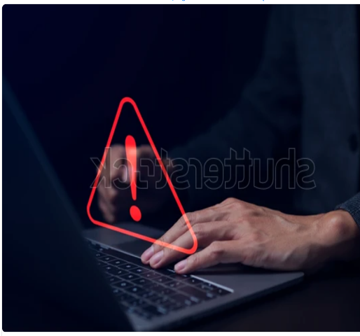

Testimonial

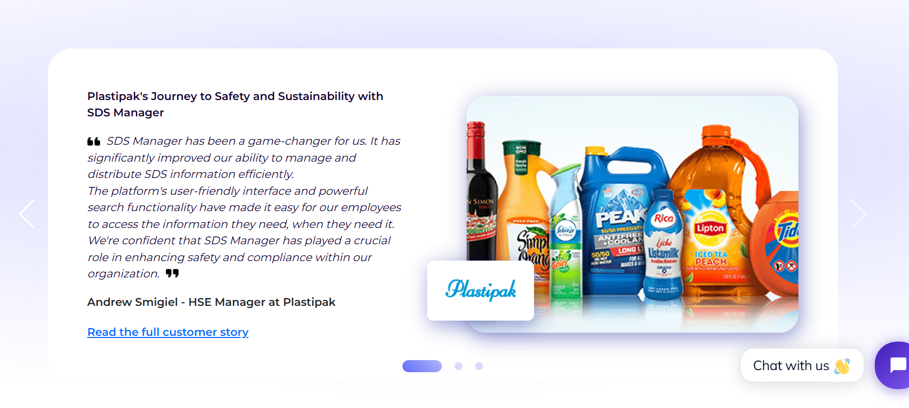

FAQ

How much does it cost to generate an SDS?

Ans: It’s free! You can generate as many as you want for free.

How can I distribute the generated SDS?

Ans: You can distribute it by mailing your team.

Can I edit the generated SDS?

Ans: Of course you can. The SDS generated is editable until you download or print it.

How long will the SDS be stored in my system?

Ans: For a lifetime. If you don’t delete it, you will always find it in your system.

Do I need to install any software to generate SDS?   
Ans: No, our Authoring Software is all you need.

Can I revise my generated SDS in the future?

Ans: You can draft your SDS to edit, update, or revise according to your needs at any time.